17. William Faulkner, “Nobel Prize Acceptance Speech”
December 10, 1950; Stockholm, Sweden
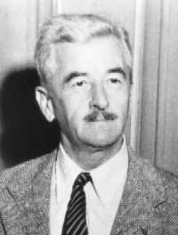
A true master of the written word, William Faulkner did not often make public his gift for the spoken variety. So there was some interest as to what he would say when accepting the Nobel Peace Prize for his “powerful and artistically unique contribution to the modern American novel.” The year was 1950, the Soviet Union had tapped the potential of the atomic bomb, and the atmosphere in the the United States crackled with the fear of them using it. Faulkner challenged poets, authors, and all mankind to think beyond the questions of “When will I be blown up?” and instead continue to “create out of the materials of the human spirit something which did not exist before.”
Worthy Excerpt:
I decline to accept the end of man. It is easy enough to say that man is immortal because he will endure: that when the last ding-dong of doom has clanged and faded from the last worthless rock hanging tideless in the last red and dying evening, that even then there will still be one more sound: that of his puny inexhaustible voice, still talking. I refuse to accept this. I believe that man will not merely endure: he will prevail. He is immortal, not because he alone among creatures has an inexhaustible voice, but because he has a soul, a spirit capable of compassion and sacrifice and endurance. The poet’s, the writer’s, duty is to write about these things. It is his privilege to help man endure by lifting his heart, by reminding him of the courage and honor and hope and pride and compassion and pity and sacrifice which have been the glory of his past. The poet’s voice need not merely be the record of man, it can be one of the props, the pillars to help him endure and prevail.

1. Theodore Roosevelt, “Duties of American Citizenship”
January 26, 1883; Buffalo, New York
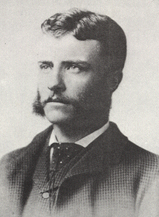
Given while serving as a New York assemblyman, TR’s address on the “Duties of American Citizenship” delved into both the theoretical reasons why every man should be involved in politics and the practical means of serving in that capacity. Roosevelt chided those who excused themselves from politics because they were too busy; it was every man’s duty to devote some time to maintaining good government.
Worthy Excerpt:
Of course, in one sense, the first essential for a man’s being a good citizen is his possession of the home virtues of which we think when we call a man by the emphatic adjective of manly. No man can be a good citizen who is not a good husband and a good father, who is not honest in his dealings with other men and women, faithful to his friends and fearless in the presence of his foes, who has not got a sound heart, a sound mind, and a sound body; exactly as no amount of attention to civil duties will save a nation if the domestic life is undermined, or there is lack of the rude military virtues which alone can assure a country’s position in the world. In a free republic the ideal citizen must be one willing and able to take arms for the defense of the flag, exactly as the ideal citizen must be the father of many healthy children. A race must be strong and vigorous; it must be a race of good fighters and good breeders, else its wisdom will come to naught and its virtue be ineffective; and no sweetness and delicacy, no love for and appreciation of beauty in art or literature, no capacity for building up material prosperity can possibly atone for the lack of the great virile virtues.
But this is aside from my subject, for what I wish to talk of is the attitude of the American citizen in civic life. It ought to be axiomatic in this country that every man must devote a reasonable share of his time to doing his duty in the Political life of the community. No man has a right to shirk his political duties under whatever plea of pleasure or business; and while such shirking may be pardoned in those of small cleans it is entirely unpardonable in those among whom it is most common–in the people whose circumstances give them freedom in the struggle for life. In so far as the community grows to think rightly, it will likewise grow to regard the young man of means who shirks his duty to the State in time of peace as being only one degree worse than the man who thus shirks it in time of war. A great many of our men in business, or of our young men who are bent on enjoying life (as they have a perfect right to do if only they do not sacrifice other things to enjoyment), rather plume themselves upon being good citizens if they even vote; yet voting is the very least of their duties, Nothing worth gaining is ever gained without effort. You can no more have freedom without striving and suffering for it than you can win success as a banker or a lawyer without labor and effort, without self-denial in youth and the display of a ready and alert intelligence in middle age. The people who say that they have not time to attend to politics are simply saying that they are unfit to live in a free community.

2. Winston Churchill, “We Shall Fight on the Beaches”
June 4, 1940; House of Commons, London
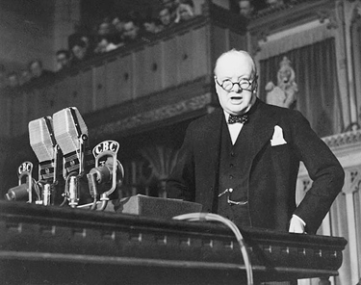
Winston Churchill, one of the greatest orators of the 20th century, was interestingly enough, like Demosthenes and other great orators before him, born with a speech impediment which he worked on until it no longer hindered him. One would never guess this from hearing Churchill’s strong and reassuring voice, a voice that would buoy up Britain during some of her darkest hours.
During the Battle of France, Allied Forces became cut off from troops south of the German penetration and perilously trapped at the Dunkirk bridgehead. On May 26, a wholesale evacuation of these troops, dubbed “Operation Dynamo,” began. The evacuation was an amazing effort-the RAF kept the Luftwaffe at bay while thousands of ships, from military destroyers to small fishing boats, were used to ferry 338,000 French and British troops to safety, far more than anyone had thought possible. On June 4, Churchill spoke before the House of Commons, giving a report which celebrated the “miraculous deliverance” at Dunkirk, while also seeking to temper a too rosy of view of what was on the whole a “colossal military disaster.”
Worthy Excerpt:
I have, myself, full confidence that if all do their duty, if nothing is neglected, and if the best arrangements are made, as they are being made, we shall prove ourselves once again able to defend our Island home, to ride out the storm of war, and to outlive the menace of tyranny, if necessary for years, if necessary alone. At any rate, that is what we are going to try to do. That is the resolve of His Majesty’s Government-every man of them. That is the will of Parliament and the nation. The British Empire and the French Republic, linked together in their cause and in their need, will defend to the death their native soil, aiding each other like good comrades to the utmost of their strength. Even though large tracts of Europe and many old and famous States have fallen or may fall into the grip of the Gestapo and all the odious apparatus of Nazi rule, we shall not flag or fail. We shall go on to the end, we shall fight in France, we shall fight on the seas and oceans, we shall fight with growing confidence and growing strength in the air, we shall defend our Island, whatever the cost may be, we shall fight on the beaches, we shall fight on the landing grounds, we shall fight in the fields and in the streets, we shall fight in the hills; we shall never surrender, and even if, which I do not for a moment believe, this Island or a large part of it were subjugated and starving, then our Empire beyond the seas, armed and guarded by the British Fleet, would carry on the struggle, until, in God’s good time, the New World, with all its power and might, steps forth to the rescue and the liberation of the old.

7. Ronald Reagan, “Address to the Nation on the Challenger”
January 28, 1986; Washington, D.C.
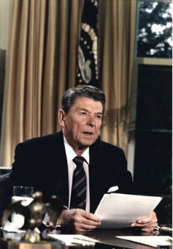
On January 28, 1986, millions of Americans, many of them schoolchildren watching from their classroom desks, tuned in to see 7 Americans, including Christa McAuliffe, a 37 year old schoolteacher and the first ever “civilian astronaut,” lift off in the space shuttle Challenger. Just 73 seconds later, the shuttle was consumed in a fireball. All seven aboard perished. These were the first deaths of American astronauts while in flight, and the nation was shocked and heartbroken by the tragedy. Just a few hours after the disaster, President Ronald Reagan took to the radio and airwaves, honoring these “pioneers” and offering comfort and assurance to a rattled people.
Worthy Excerpt:
For the families of the seven, we cannot bear, as you do, the full impact of this tragedy. But we feel the loss, and we’re thinking about you so very much. Your loved ones were daring and brave, and they had that special grace, that special spirit that says, ‘Give me a challenge and I’ll meet it with joy.’ They had a hunger to explore the universe and discover its truths. They wished to serve, and they did. They served all of us.
We’ve grown used to wonders in this century. It’s hard to dazzle us. But for twenty-five years the United States space program has been doing just that. We’ve grown used to the idea of space, and perhaps we forget that we’ve only just begun. We’re still pioneers. They, the members of the Challenger crew, were pioneers.
And I want to say something to the schoolchildren of America who were watching the live coverage of the shuttle’s takeoff. I know it is hard to understand, but sometimes painful things like this happen. It’s all part of the process of exploration and discovery. It’s all part of taking a chance and expanding man’s horizons. The future doesn’t belong to the fainthearted; it belongs to the brave. The Challenger crew was pulling us into the future, and we’ll continue to follow them.
I’ve always had great faith in and respect for our space program, and what happened today does nothing to diminish it. We don’t hide our space program. We don’t keep secrets and cover things up. We do it all up front and in public. That’s the way freedom is, and we wouldn’t change it for a minute. We’ll continue our quest in space. There will be more shuttle flights and more shuttle crews and, yes, more volunteers, more civilians, more teachers in space. Nothing ends here; our hopes and our journeys continue. I want to add that I wish I could talk to every man and woman who works for NASA or who worked on this mission and tell them: “Your dedication and professionalism have moved and impressed us for decades. And we know of your anguish. We share it.”
The crew of the space shuttle Challenger honoured us by the manner in which they lived their lives. We will never forget them, nor the last time we saw them, this morning, as they prepared for the journey and waved goodbye and ‘slipped the surly bonds of earth’ to ‘touch the face of God.’
Thank you.

15. Mahatma Gandhi, “Quit India”
August 8, 1942; India
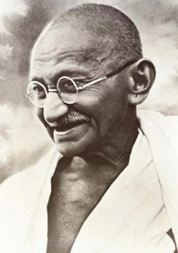
While the battle for freedom and democracy raged across the world, the people of India were engaged in their own fight for liberty. For almost a century, India had been under the direct rule of the British crown, and many Indians had had enough. Mahatma Gandhi and the National Indian Congress pushed for a completely non-violent movement aimed at forcing Britain to “Quit India.” Gandhi, pioneer of the tactics of non-violent civil disobedience, called for their use on August 8, 1942 with the passing of the Quit India Resolution demanding complete independence from British rule.
Worthy Excerpt:
Occasions like the present do not occur in everybody’s and but rarely in anybody’s life. I want you to know and feel that there is nothing but purest Ahimsa1 in all that I am saying and doing today. The draft resolution of the Working Committee is based on Ahimsa, the contemplated struggle similarly has its roots in Ahimsa. If, therefore, there is any among you who has lost faith in Ahimsa or is wearied of it, let him not vote for this resolution.
Let me explain my position clearly. God has vouchsafed to me a priceless gift in the weapon of Ahimsa. I and my Ahimsa are on our trail today. If in the present crisis, when the earth is being scorched by the flames of Himsa2 and crying for deliverance, I failed to make use of the God given talent, God will not forgive me and I shall be judged un-wrongly of the great gift. I must act now. I may not hesitate and merely look on, when Russia and China are threatened.
Ours is not a drive for power, but purely a non-violent fight for India’s independence. In a violent struggle, a successful general has been often known to effect a military coup and to set up a dictatorship. But under the Congress scheme of things, essentially non-violent as it is, there can be no room for dictatorship. A non-violent soldier of freedom will covet nothing for himself, he fights only for the freedom of his country. The Congress is unconcerned as to who will rule, when freedom is attained. The power, when it comes, will belong to the people of India, and it will be for them to decide to whom it placed in the entrusted. May be that the reins will be placed in the hands of the Parsis, for instance-as I would love to see happen-or they may be handed to some others whose names are not heard in the Congress today. It will not be for you then to object saying, “This community is microscopic. That party did not play its due part in the freedom’s struggle; why should it have all the power?” Ever since its inception the Congress has kept itself meticulously free of the communal taint. It has thought always in terms of the whole nation and has acted accordingly. . .
I know how imperfect our Ahimsa is and how far away we are still from the ideal, but in Ahimsa there is no final failure or defeat. I have faith, therefore, that if, in spite of our shortcomings, the big thing does happen, it will be because God wanted to help us by crowning with success our silent, unremitting Sadhana1 for the last twenty-two years.
I believe that in the history of the world, there has not been a more genuinely democratic struggle for freedom than ours. I read Carlyle’s French Resolution while I was in prison, and Pandit Jawaharlal has told me something about the Russian revolution. But it is my conviction that inasmuch as these struggles were fought with the weapon of violence they failed to realize the democratic ideal. In the democracy which I have envisaged, a democracy established by non-violence, there will be equal freedom for all. Everybody will be his own master. It is to join a struggle for such democracy that I invite you today. Once you realize this you will forget the differences between the Hindus and Muslims, and think of yourselves as Indians only, engaged in the common struggle for independence.
1 Ahimsa-respect for all living things and avoidance of violence toward others.

23. Theodore Roosevelt, “Strength and Decency”
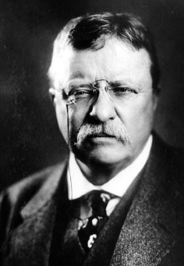
Roosevelt was an advocate of having many children and making sure the next generation would continue to uphold the great virtues of civilization. He was always concerned that young men not be coddled or cowardly, and grow up to live rugged, strenuous, and thoroughly manly lives. But he also strongly believed that being ruggedly manly and being refined in mind and spirit were not incompatible and should in fact go hand and hand. In this speech, he exhorts young men to pursue virtuous manliness. Amen, brother, amen.
Worthy Excerpt:
It is peculiarly incumbent upon you who have strength to set a right example to others. I ask you to remember that you cannot retain your self-respect if you are loose and foul of tongue, that a man who is to lead a clean and honorable life must inevitably suffer if his speech likewise is not clean and honorable. Every man here knows the temptations that beset all of us in this world. At times any man will slip. I do not expect perfection, but I do expect genuine and sincere effort toward being decent and cleanly in thought, in word, and in deed. As I said at the outset, I hail the work of this society as typifying one of those forces which tend to the betterment and uplifting of our social system. Our whole effort should be toward securing a combination of the strong qualities with those qualities which we term virtues. I expect you to be strong. I would not respect you if you were not. I do not want to see Christianity professed only by weaklings; I want to see it a moving spirit among men of strength. I do not expect you to lose one particle of your strength or courage by being decent. On the contrary, I should hope to see each man who is a member of this society, from his membership in it become all the fitter to do the rough work of the world; all the fitter to work in time of peace; and if, which may Heaven forfend, war should come, all the fitter to fight in time of war. I desire to see in this country the decent men strong and the strong men decent, and until we get that combination in pretty good shape we are not going to be by any means as successful as we should be. There is always a tendency among very young men and among boys who are not quite young men as yet to think that to be wicked is rather smart; to think it shows that they are men. Oh, how often you see some young fellow who boasts that he is going to “see life,” meaning by that that he is going to see that part of life which it is a thousandfold better should remain unseen!

28. Frederick Douglass, “What to the Slave is the Fourth of July?”
July 5, 1852; Rochester, NY
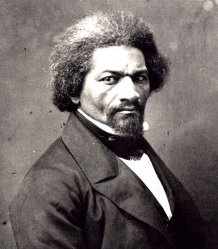
Frederick Douglass, former slave, abolitionist, and engineer on the underground railroad, was a popular speaker on the anti-slavery circuit. He traveled thousands of miles each year, giving hundreds of speeches. Yet the money he earned from lecturing was not enough to become financially comfortable, and he and his family struggled. Douglass was disillusioned by the repercussions of the Fugitive Slave Act, and his abolitionist leanings grew more strident and bold. If the citizens of Rochester, New York had expected to be flattered by Douglass when they asked him to speak on the Fourth, they were soon disavowed of that idea. Douglass took the opportunity to defiantly point out the ripe hypocrisy of a nation celebrating their ideals of freedom and equality while simultaneously mired in the evil of slavery. While the speech surely made even the most liberal audience members squirm; nonetheless, the crowed let loose in “universal applause” when Douglass finished.
Worthy Excerpt:
For the present, it is enough to affirm the equal manhood of the Negro race. Is it not astonishing that, while we are ploughing, planting, and reaping, using all kinds of mechanical tools, erecting houses, constructing bridges, building ships, working in metals of brass, iron, copper, silver and gold; that, while we are reading, writing and ciphering, acting as clerks, merchants and secretaries, having among us lawyers, doctors, ministers, poets, authors, editors, orators and teachers; that, while we are engaged in all manner of enterprises common to other men, digging gold in California, capturing the whale in the Pacific, feeding sheep and cattle on the hill-side, living, moving, acting, thinking, planning, living in families as husbands, wives and children, and, above all, confessing and worshipping the Christian’s God, and looking hopefully for life and immortality beyond the grave, we are called upon to prove that we are men!
What, am I to argue that it is wrong to make men brutes, to rob them of their liberty, to work them without wages, to keep them ignorant of their relations to their fellow men, to beat them with sticks, to flay their flesh with the lash, to load their limbs with irons, to hunt them with dogs, to sell them at auction, to sunder their families, to knock out their teeth, to burn their flesh, to starve them into obedience and submission to their mastcrs? Must I argue that a system thus marked with blood, and stained with pollution, is wrong? No! I will not. I have better employment for my time and strength than such arguments would imply.
What, then, remains to be argued? Is it that slavery is not divine; that God did not establish it; that our doctors of divinity are mistaken? There is blasphemy in the thought. That which is inhuman, cannot be divine! Who can reason on such a proposition? They that can, may; I cannot. The time for such argument is passed.
At a time like this, scorching irony, not convincing argument, is needed. O! had I the ability, and could reach the nation’s ear, I would, to-day, pour out a fiery stream of biting ridicule, blasting reproach, withering sarcasm, and stern rebuke. For it is not light that is needed, but fire; it is not the gentle shower, but thunder. We need the storm, the whirlwind, and the earthquake. The feeling of the nation must be quickened; the conscience of the nation must be roused; the propriety of the nation must be startled; the hypocrisy of the nation must be exposed; and its crimes against God and man must be proclaimed and denounced. There is not a man beneath the canopy of heaven that does not know that slavery is wrong for him.
What, to the American slave, is your 4th of July? I answer; a day that reveals to him, more than all other days in the year, the gross injustice and cruelty to which he is the constant victim. To him, your celebration is a sham; your boasted liberty, an unholy license; your national greatness, swelling vanity; your sounds of rejoicing are empty and heartless; your denunciation of tyrants, brass fronted impudence; your shouts of liberty and equality, hollow mockery; your prayers and hymns, your sermons and thanksgivings, with all your religious parade and solemnity, are, to Him, mere bombast, fraud, deception, impiety, and hypocrisy — a thin veil to cover up crimes which would disgrace a nation of savages. There is not a nation on the earth guilty of practices more shocking and bloody than are the people of the United States, at this very hour.

33. Jesus Christ, “The Sermon on the Mount”
33 A.D. Jerusalem
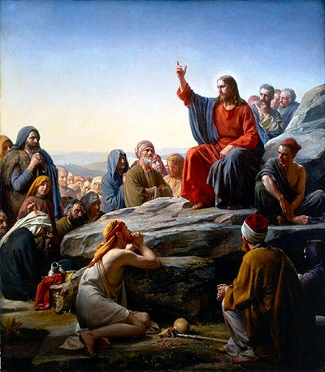
Whether one believes that Jesus of Nazareth was the Son of God or simply a wise teacher, it is impossible to deny the impact of perhaps the world’s most famous speech: The Sermon on the Mount. No speech has been more pondered, more influential, or more quoted. It introduced a prayer now familiar the world over and uttered in trenches, churches, and bedsides around the globe. It introduced a code of conduct billions of believers have adopted as their lofty, if not not always attainable, goal. While much of the sermon has roots in Jewish law, the advice given in the Beatitudes represented a dramatic and radical departure from the eye for an eye system of justice known in the ancient world. The standards of behavior outlined in the sermon have given believers and non-believers alike plenty to contemplate and discuss in the two thousand years since it was given. The text is deceptively simple, so to analyze its rhetorical effectiveness, one must contemplate the “levels” of meaning and significance in the instructions given.
Worthy Excerpt:
Blessed are the poor in spirit: for theirs is the kingdom of heaven.
Blessed are they that mourn: for they shall be comforted.
Blessed are the meek: for they shall inherit the earth.
Blessed are they which do hunger and thirst after
righteousness: for they shall be filled.
Blessed are the merciful: for they shall obtain mercy.
Blessed are the pure in heart: for they shall see God.
Blessed are the peacemakers: for they shall be called the
children of God.

Blessed are they which are persecuted for righteousness’ sake:
for theirs is the kingdom of heaven.

